Rapport

[TP4-BDD]

[Batiche Chourouq – G3]

Q-20- SELECT \* FROM Publisher  WHERE headquarterslocation ='London uk'; 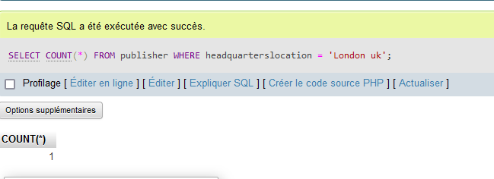

Q-21- SELECT \* FROM books ORDER BY publication\_date DESC LIMIT 10;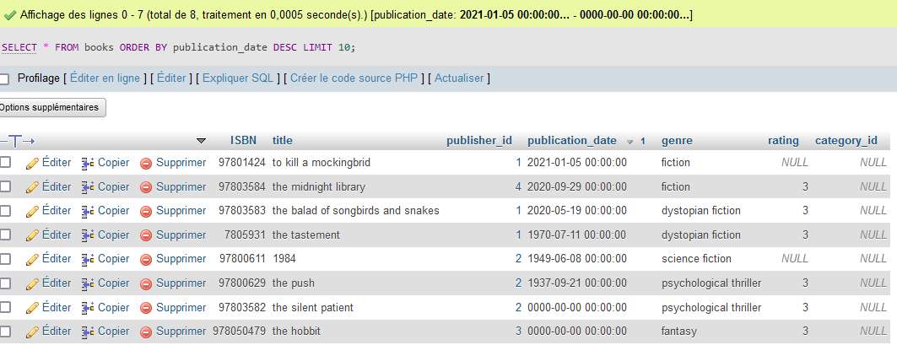

Q-22- SELECT AVG(YEAR(publication\_date)) AS average\_publication\_year FROM books;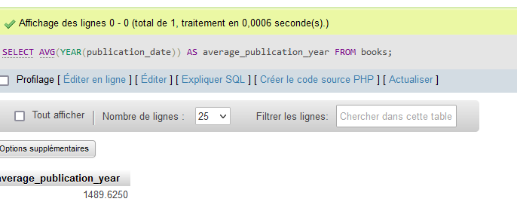

Q-23- SELECT \* FROM members WHERE member\_email LIKE '% @gmail.com'OR email LIKE '%@yahoo.com';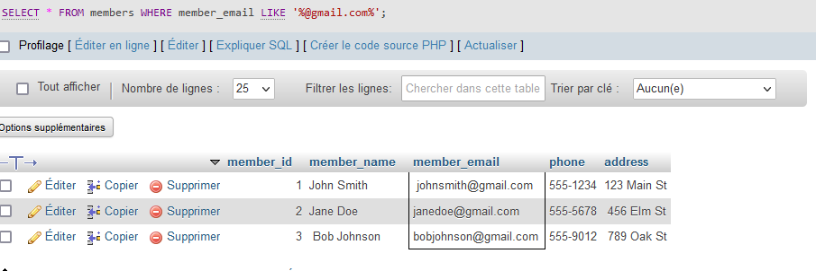

Q-24- SELECT \* FROM authors WHERE country IN ( 'USA' , 'UK');

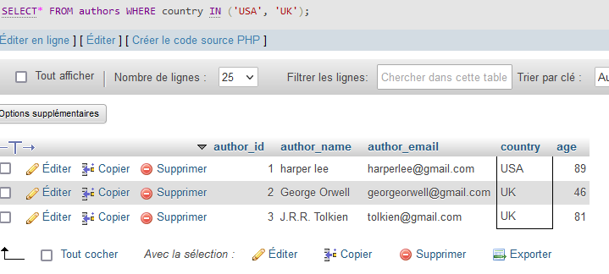

Q-25- SELECT title FROM books WHERE YEAR(Publication\_date) IN (2020,2021)

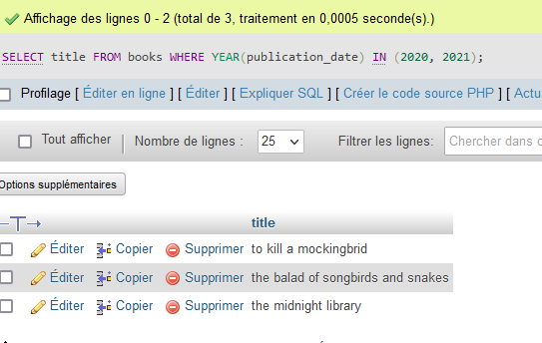

Q-26- SELECT \* CASE WHEN address LIKE ‘%California%’ WHEN address LIKE ‘%New York’ ELSE ‘Others’ END AS state\_category FROM members;  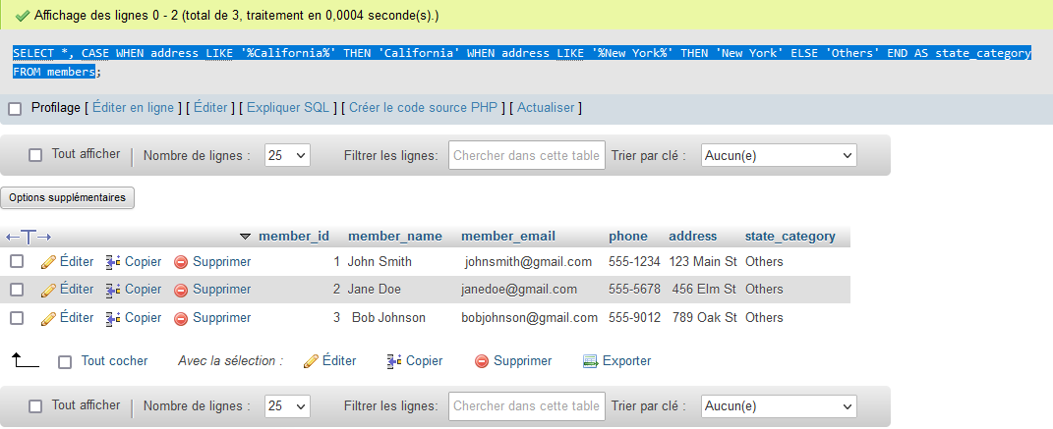

Q-27-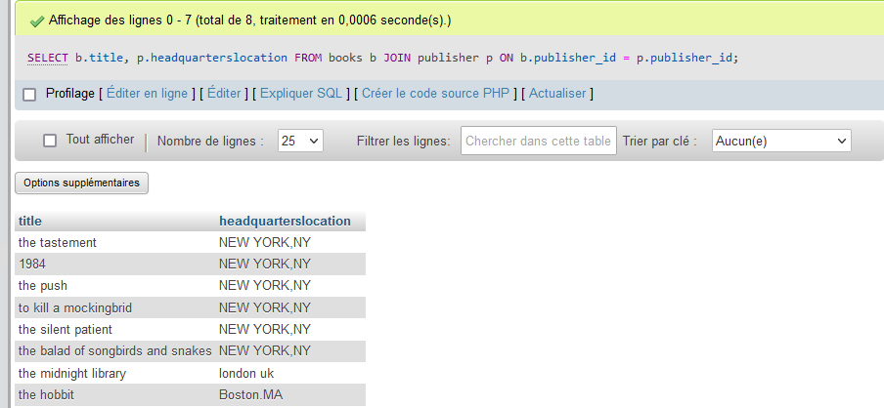

Q-28-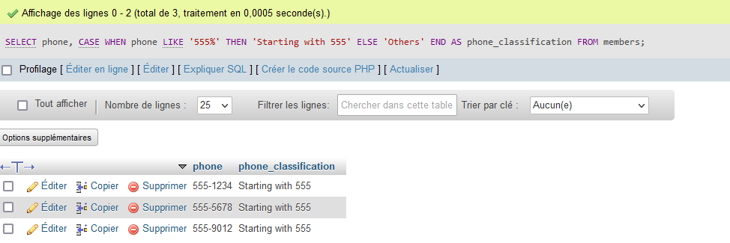

Q-29- [SELECT](http://localhost/phpmyadmin/url.php?url=https://dev.mysql.com/doc/refman/8.0/en/select.html) b.title, p.website FROM books b JOIN publisher p ON b.publisher\_id = p.publisher\_id WHERE YEAR(b.publication\_date) < 2000 [AND](http://localhost/phpmyadmin/url.php?url=https://dev.mysql.com/doc/refman/8.0/en/logical-operators.html%23operator_and) p.foundationyear < 1950

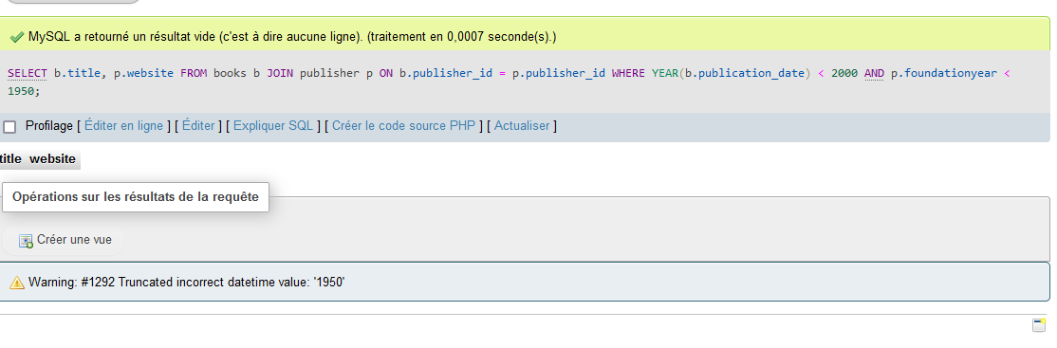

Q-30- SELECT title FROM books WHERE publication\_date > (

SELECT MAX(publication\_date)FROM books

WHERE YEAR(publication\_date) = 2020

);

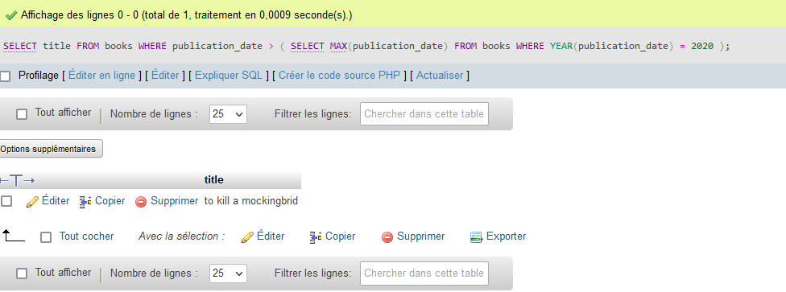

Q-31- [SELECT](http://localhost/phpmyadmin/url.php?url=https://dev.mysql.com/doc/refman/8.0/en/select.html) title FROM books WHERE publication\_date > ( [SELECT](http://localhost/phpmyadmin/url.php?url=https://dev.mysql.com/doc/refman/8.0/en/select.html) [MAX](http://localhost/phpmyadmin/url.php?url=https://dev.mysql.com/doc/refman/8.0/en/aggregate-functions.html%23function_max)(publication\_date) FROM books WHERE YEAR(publication\_date) = 2015 );

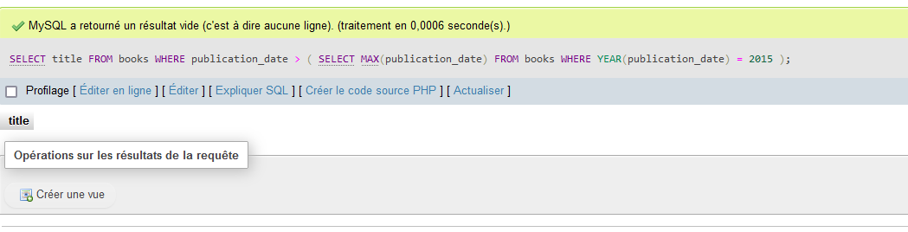

Q-32- [SELECT](http://localhost/phpmyadmin/url.php?url=https://dev.mysql.com/doc/refman/8.0/en/select.html) b.title FROM books b JOIN publisher p ON b.publisher\_id = p.publisher\_id WHERE b.publisher\_id [IS](http://localhost/phpmyadmin/url.php?url=https://dev.mysql.com/doc/refman/8.0/en/comparison-operators.html%23operator_is) [NOT](http://localhost/phpmyadmin/url.php?url=https://dev.mysql.com/doc/refman/8.0/en/logical-operators.html%23operator_not) NULL [AND](http://localhost/phpmyadmin/url.php?url=https://dev.mysql.com/doc/refman/8.0/en/logical-operators.html%23operator_and) b.publisher\_id [IN](http://localhost/phpmyadmin/url.php?url=https://dev.mysql.com/doc/refman/8.0/en/comparison-operators.html%23function_in) ( [SELECT](http://localhost/phpmyadmin/url.php?url=https://dev.mysql.com/doc/refman/8.0/en/select.html) publisher\_id FROM publisher WHERE headquarterslocation = p.headquarterslocation ); 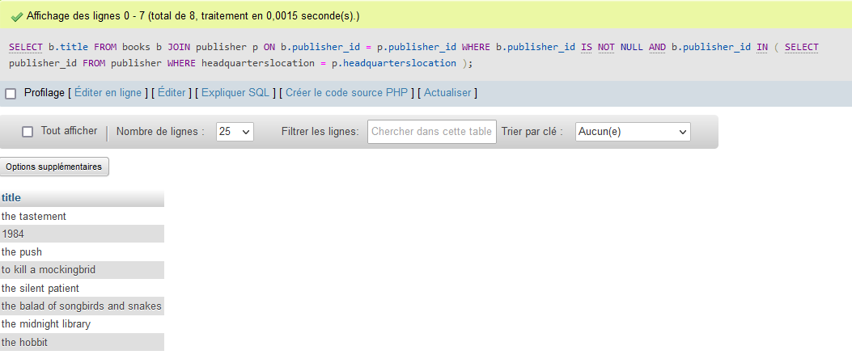

Q-33- [SELECT](http://localhost/phpmyadmin/url.php?url=https://dev.mysql.com/doc/refman/8.0/en/select.html) author\_name FROM authors WHERE author\_name [NOT](http://localhost/phpmyadmin/url.php?url=https://dev.mysql.com/doc/refman/8.0/en/logical-operators.html%23operator_not) [IN](http://localhost/phpmyadmin/url.php?url=https://dev.mysql.com/doc/refman/8.0/en/comparison-operators.html%23function_in) ( [SELECT](http://localhost/phpmyadmin/url.php?url=https://dev.mysql.com/doc/refman/8.0/en/select.html) member\_name FROM members ); 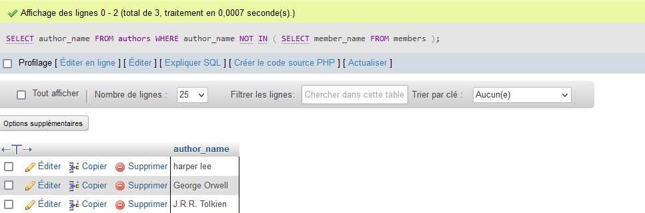

Q-34- [SELECT](http://localhost/phpmyadmin/url.php?url=https://dev.mysql.com/doc/refman/8.0/en/select.html" \t "mysql_doc) \* FROM books ORDER BY publication\_date DESC LIMIT 5 OFFSET 10;



Q-35- [SELECT](http://localhost/phpmyadmin/url.php?url=https://dev.mysql.com/doc/refman/8.0/en/select.html) a.author\_name, a.age, a.country FROM authors a JOIN ( [SELECT](http://localhost/phpmyadmin/url.php?url=https://dev.mysql.com/doc/refman/8.0/en/select.html) country, [AVG](http://localhost/phpmyadmin/url.php?url=https://dev.mysql.com/doc/refman/8.0/en/aggregate-functions.html%23function_avg)(age) AS avg\_age FROM authors GROUP BY country ) AS p ON a.country = p.country WHERE a.age > p.avg\_age;

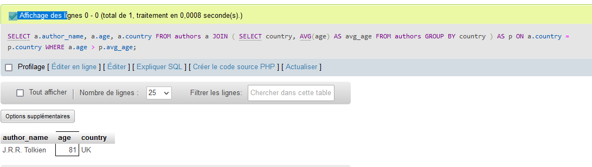

Q-36- [SELECT](http://localhost/phpmyadmin/url.php?url=https://dev.mysql.com/doc/refman/8.0/en/select.html) b.title FROM books b JOIN publisher p ON b.publisher\_id = p.publisher\_id WHERE p.headquarterslocation = 'New York,NY';

